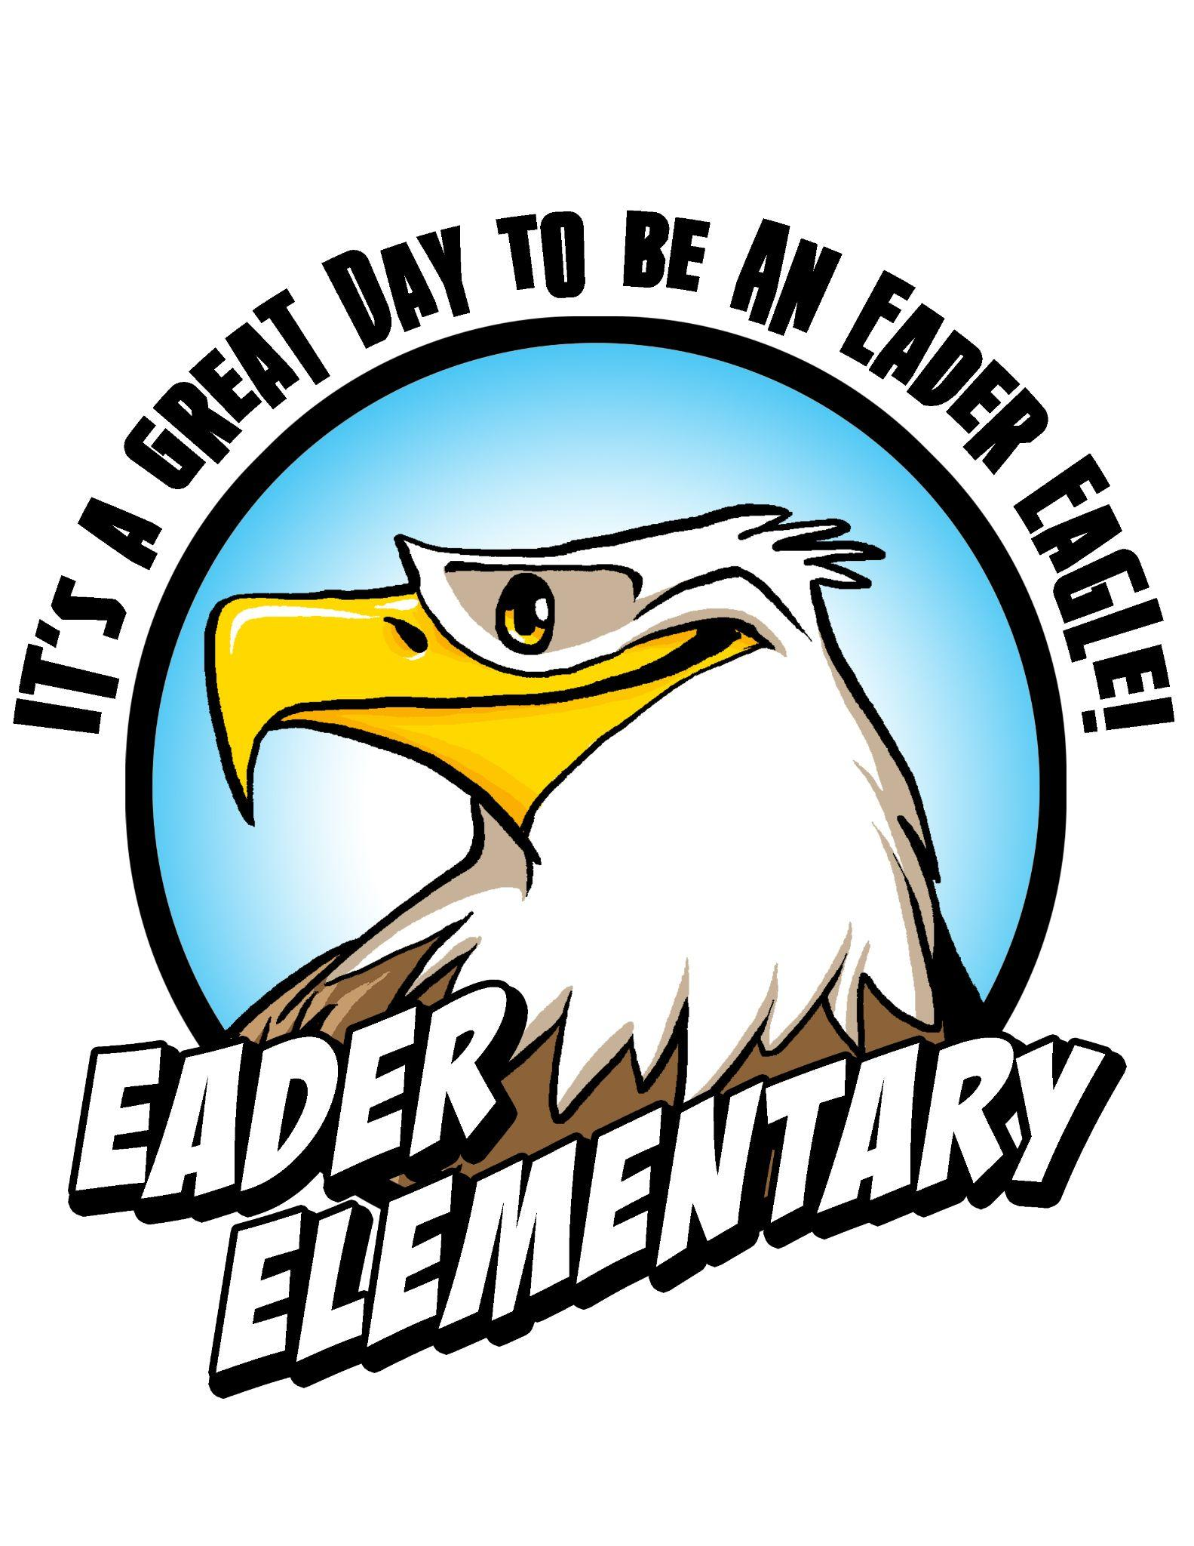

Eader Elementary PTA
Association Meeting
September 10, 2021/ Eader Elementary

Agenda

Call to Order and Pledge of Allegiance Amy McLane

Minutes of June 18, 2021 Association Meeting Secretary (Open)

- Principal’s Report Mrs. Beck

- Financial Reports Katie O’Connor

- Officer and Chairperson Reports
  - Vice President Melanee Chapman
  - Ways & Means Carolyn Reilly
  - Membership Open
  - Historian Michelle Edpao
  - Advocacy Tara Barton

- President’s Report Amy McLane

New Business

Upcoming Dates
- PTA Association Meeting - October 1st @ 9am
- Reflections Submissions Due - October 15, 2021
- Movie Night - October 21st, time TBD

